A CRM Application to Handle the Clients and their property Related Requirements

# Aim:

The project aims to design and develop a CRM (Customer Relationship Management) application using Salesforce to manage clients and their property-related information. The application will enable the organization to streamline client interactions, property management, and related services.

# Objectives:

* 1. **Client Management:** Design a client management system to store and manage client information, including contact details, property ownership, and interaction history.
  2. **Property Management:** Develop a property management system to store and manage property-related information, including property type, location, and ownership details.
  3. **Service Management:** Create a service management system to manage various services offered to clients, such as property maintenance, repairs, and renovations.
  4. **Reporting and Analytics:** Develop reports and analytics to provide insights into client interactions, property management, and service delivery.
  5. **User Adoption:** Ensure user adoption by providing an intuitive and user-friendly interface.

# Salesforce Key Features and Concepts Utilized:

* 1. **Accounts and Contacts:** Utilize Accounts and Contacts to manage client information and relationships.
  2. **Custom Objects:** Create custom objects to manage property-related information, such as Property, Property Type, and Property Ownership.
  3. **Relationships:** Establish relationships between Accounts, Contacts, and custom objects to manage complex data relationships.
  4. **Page Layouts and Views:** Design page layouts and views to provide an intuitive and user-friendly interface for users.
  5. **Workflows and Approvals:** Implement workflows and approvals to automate business processes and ensure data accuracy.
  6. **Reports and Dashboards:** Develop reports and dashboards to provide insights into client interactions, property management, and service delivery.
  7. **Security and Access**: Implement security and access controls to ensure data integrity and confidentiality.
  8. **Integration:** Integrate with external systems, such as property management software, to provide a seamless user experience.

# Detailed Steps to Solution Design:

## STEP 1:

**Milestone 1:** Create a Jotform and integrate it with the org to create a record of customers automatically.

**Activity:** To create a form to get the customer details like Name, Phone, Email, Address and type of property the customer is interested in.

**My form:** <https://form.jotform.com/jaiharini03/dreams-world>

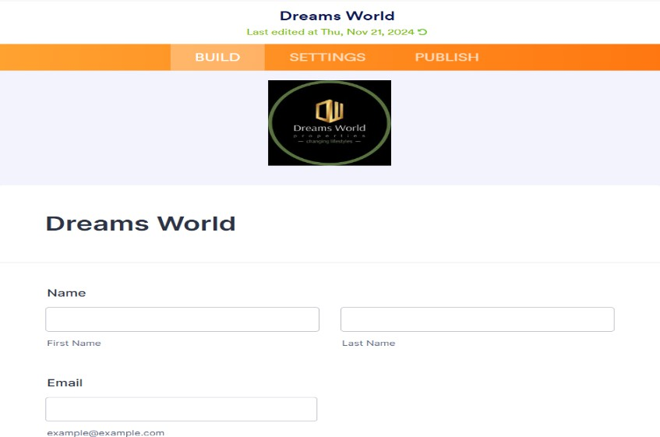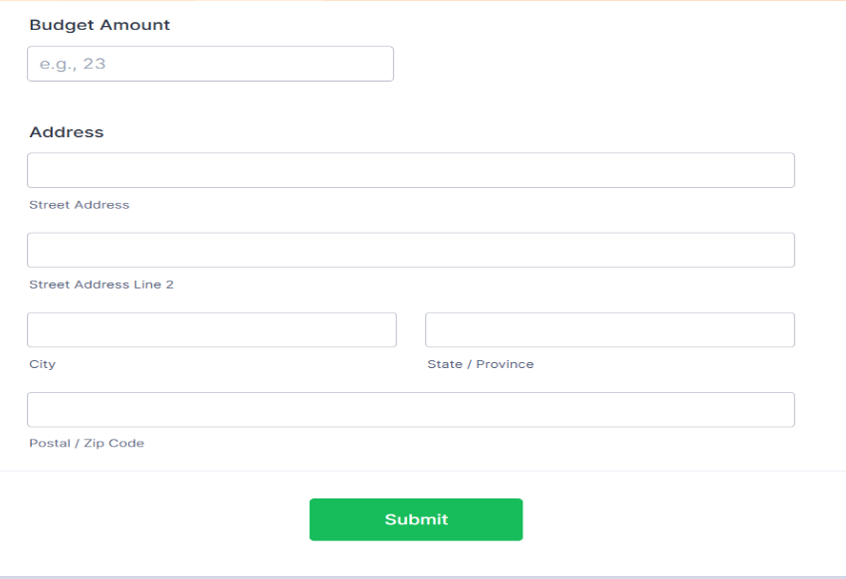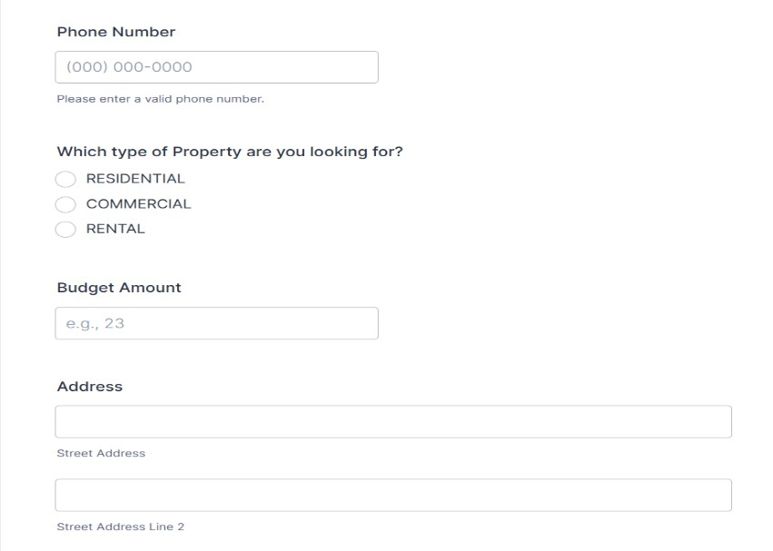

Create Objects from Spreadsheet.

**Activity 1:** Customer Object.

Go to object manager and create object from spreadsheet; map the fields and upload to create **Customer** and **Property** object.

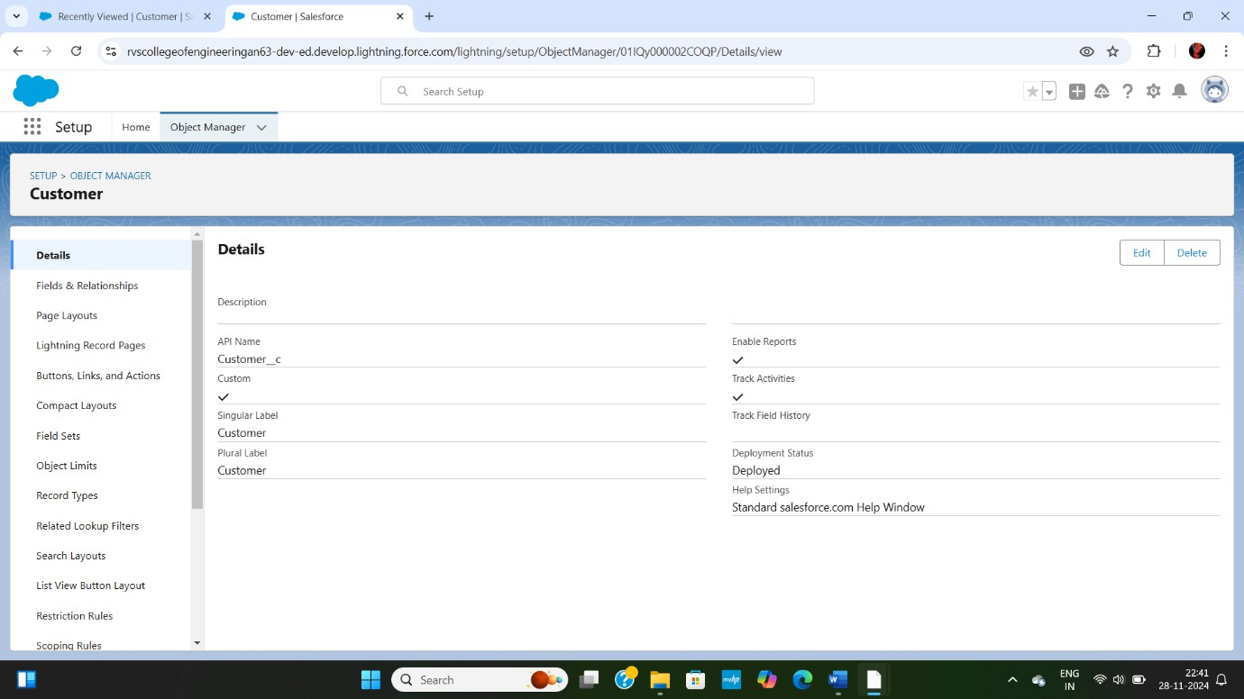

**Activity 2:** Property Object.

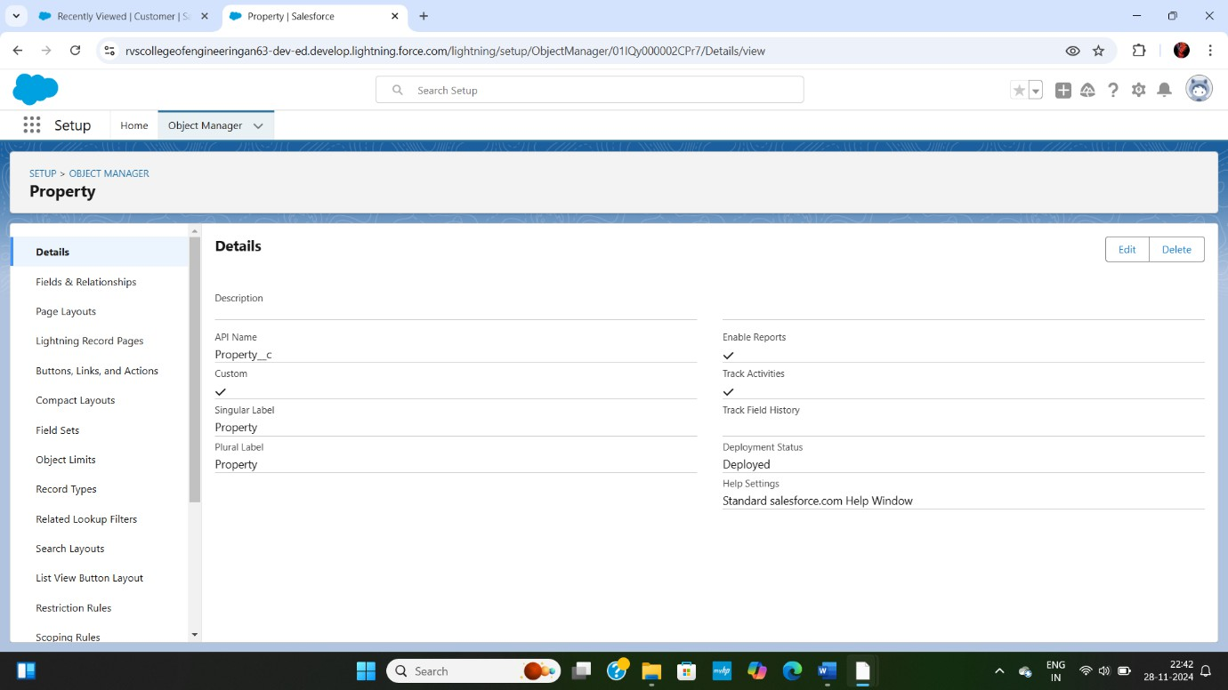

### Integrate Jotform with Salesforce Platform Activity 1:

On the Jotform Platform, Click on Integration and choose Salesforce.

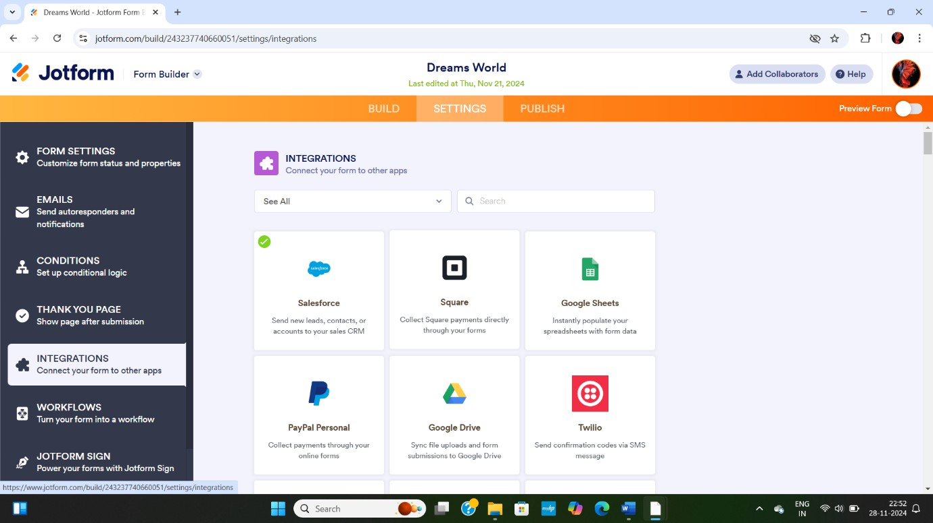

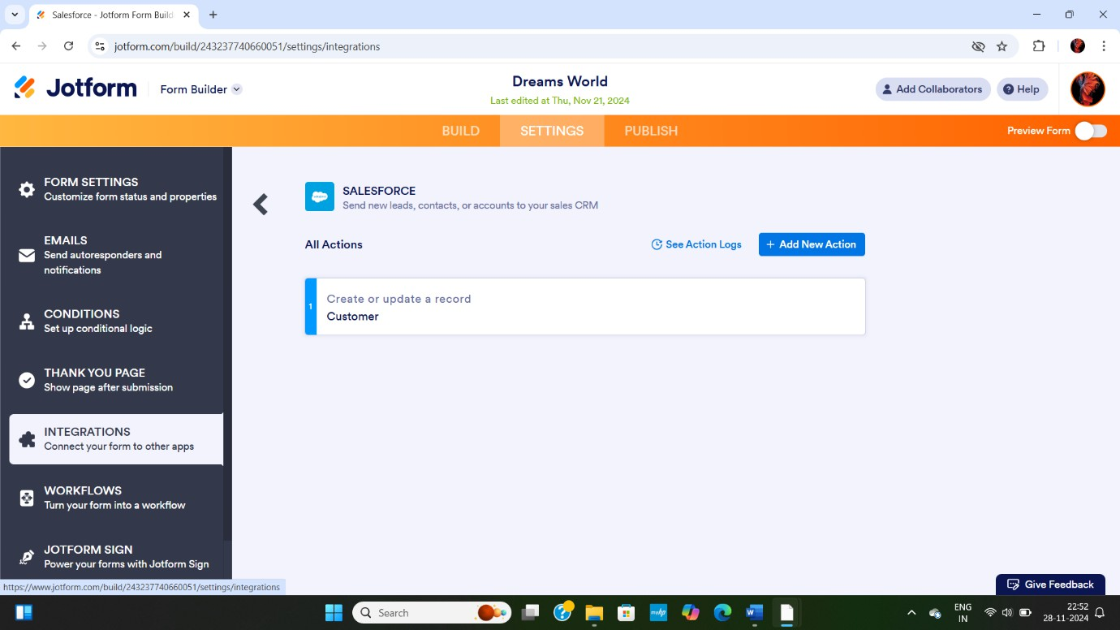

Create Roles.

### Activity:

Create **Sales Executive Role** below the Sales Representative and **Sales Manager** below Sales Executive which reports to Sales Executive, and add a role **“Customer”** which reports to Sales Manager.

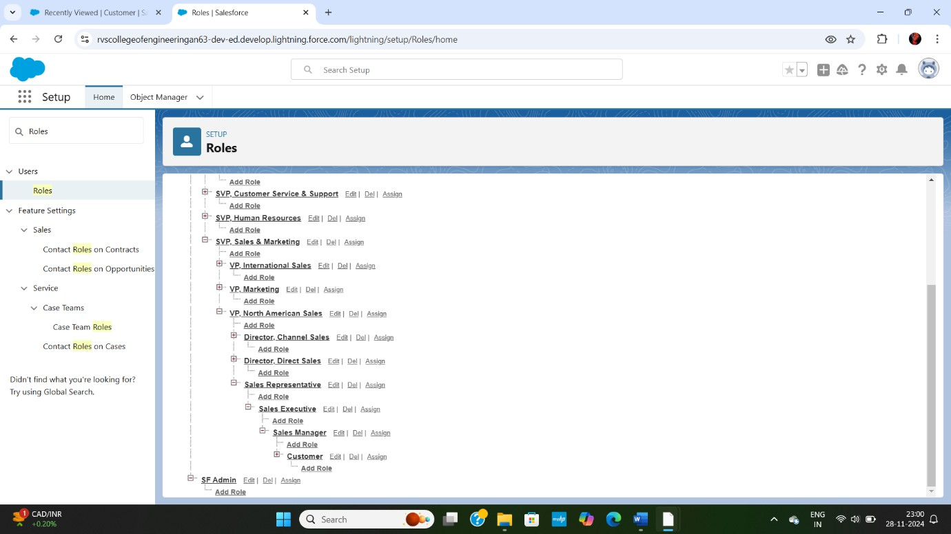

## STEP 5:

Create a Property Details App.

### Activity:

From Setup, Go to App Manager and click on New Lightning App and Name it as “Property Details” and add “Customer” and “Property” Object.

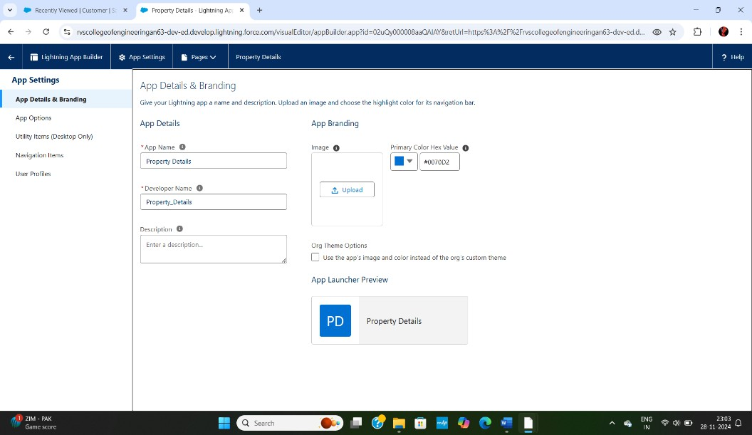

Create Profiles.

**Activity 1:** Customer

Go to Profiles and Clone Salesforce Platform User and Name it “Customer”.

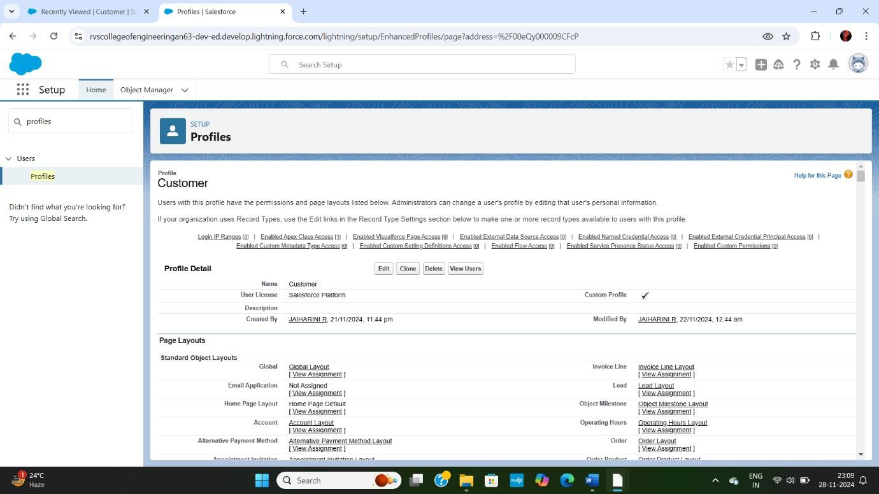

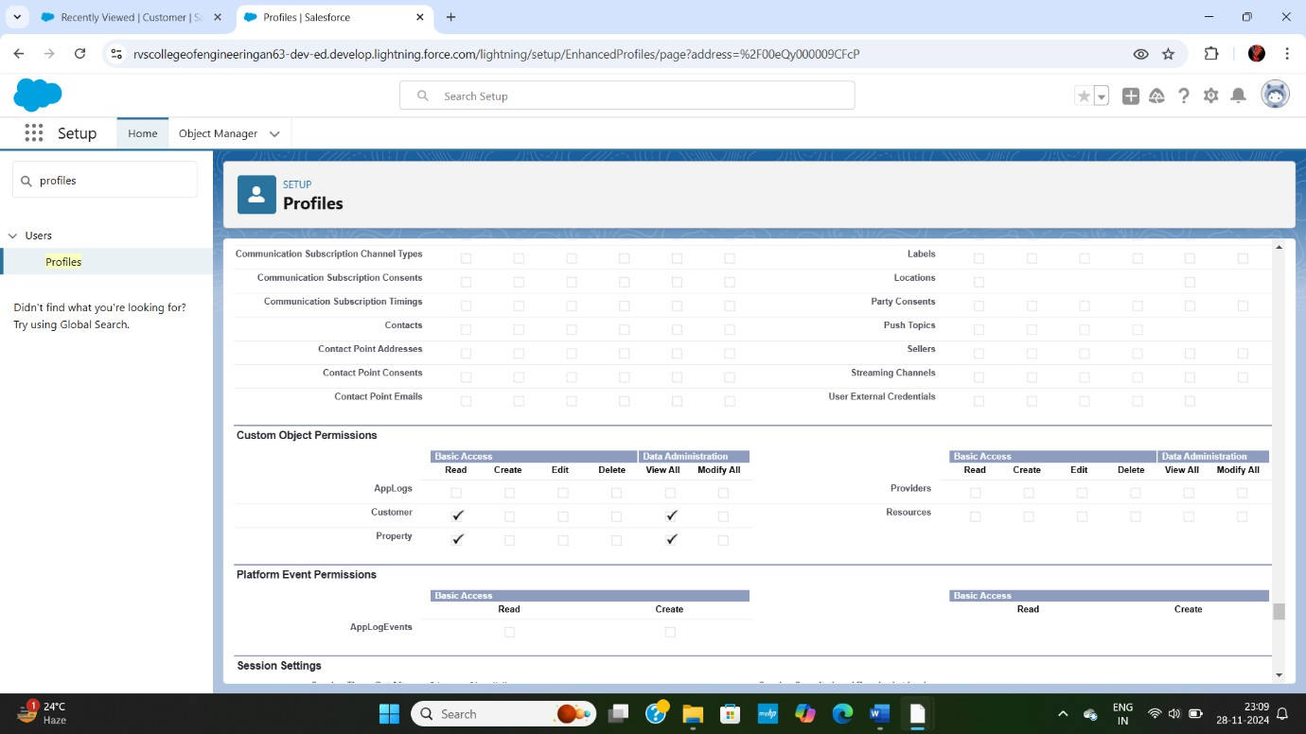

### Activity 2: Manager

Go to Profiles and Clone Salesforce Platform User and Name it “Manager”.

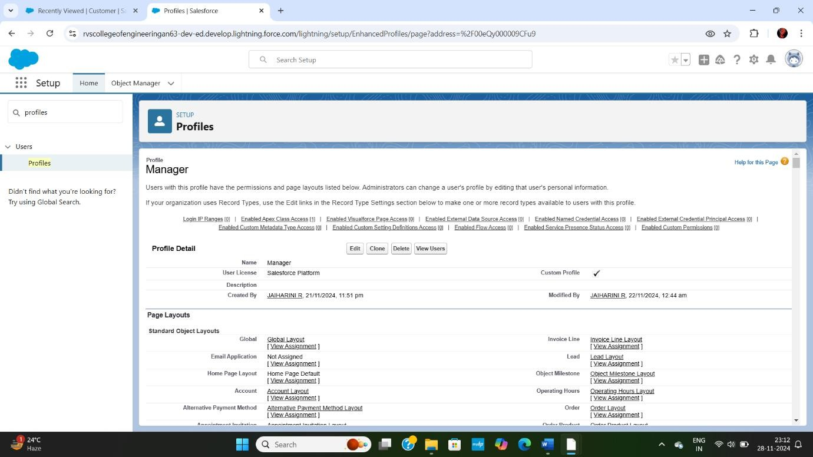

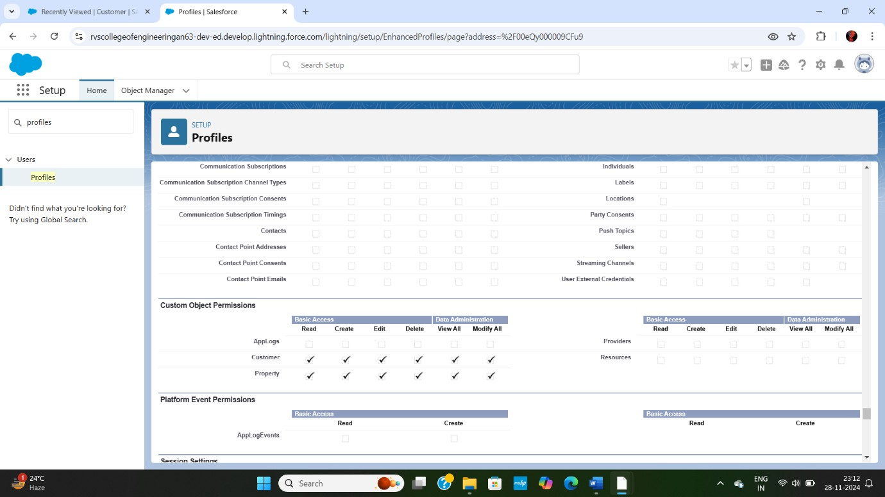

## STEP 7:

Create a Check Box field on user.

### Activity:

Create new Field Named as “Verified” as Data type **Check Box**.

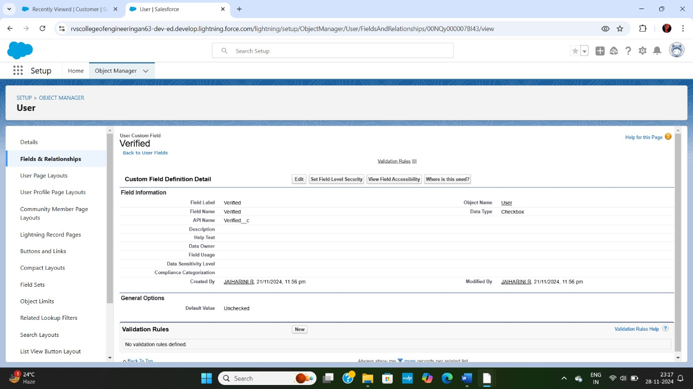

## STEP 8:

Create Users.

### Activity 1: User 1

Go to Setup ->Administration -> Users -> New User; Last Name - Executive; Role - Sales Executive; License - Salesforce; Profile - System Administrator and Save.

### Activity 2: User 2

Go to Setup ->Administration ->Users ->New User; Last Name - Manager; Role - Sales Manager; License - Salesforce Platform; Profile - Manager and Save.

### Activity 3: User 3

Go to Setup ->Administration ->Users ->New User; Last Name - Customer; Role - Customer; License - Salesforce Platform; Profile - Customer; check the verified check box is “Unchecked” and save.

### Activity 4: User 4

Go to Setup ->Administration ->Users ->New User; Last Name - Customer2; Role - Customer; License - Salesforce Platform; Profile - Customer; check the verified check box is “Unchecked” and save.

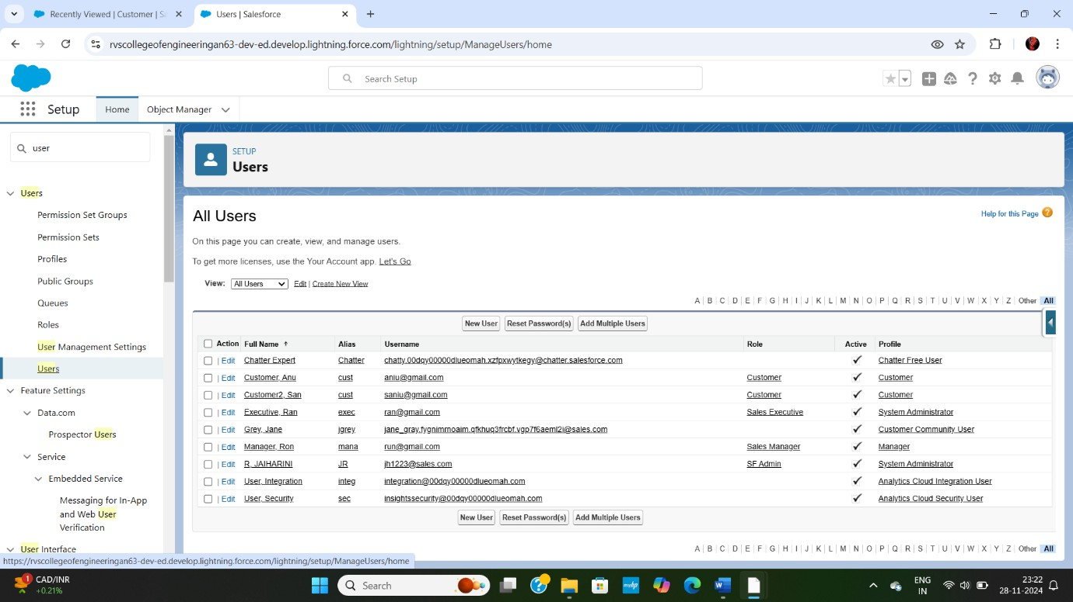

## STEP 9:

Create an Approval Process for Property Object.

### Activity:

1. From Setup to Process Automation ->Approval Process and Process Name - Property Approval.

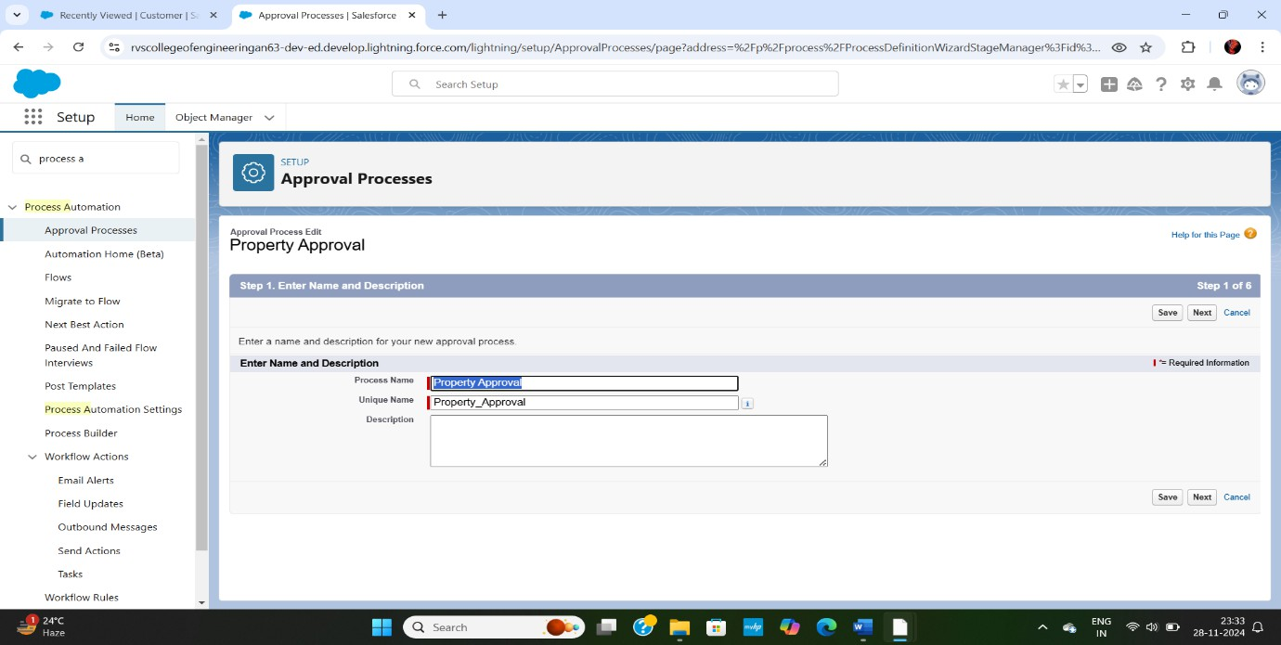

1. Give 2 criteria –> Location is not equal to blank, Verified Equals false.

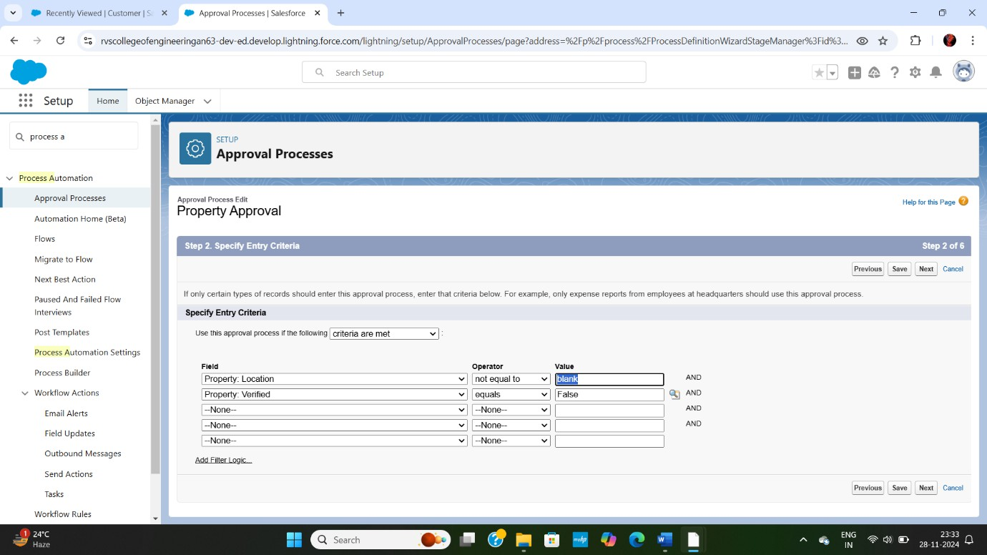

1. Click next and “Next Automated Approver Determined By” Select Manager and From Record Editability Properties >> Click on **Administrators OR the currently assigned approver can edit records during the approval process**.

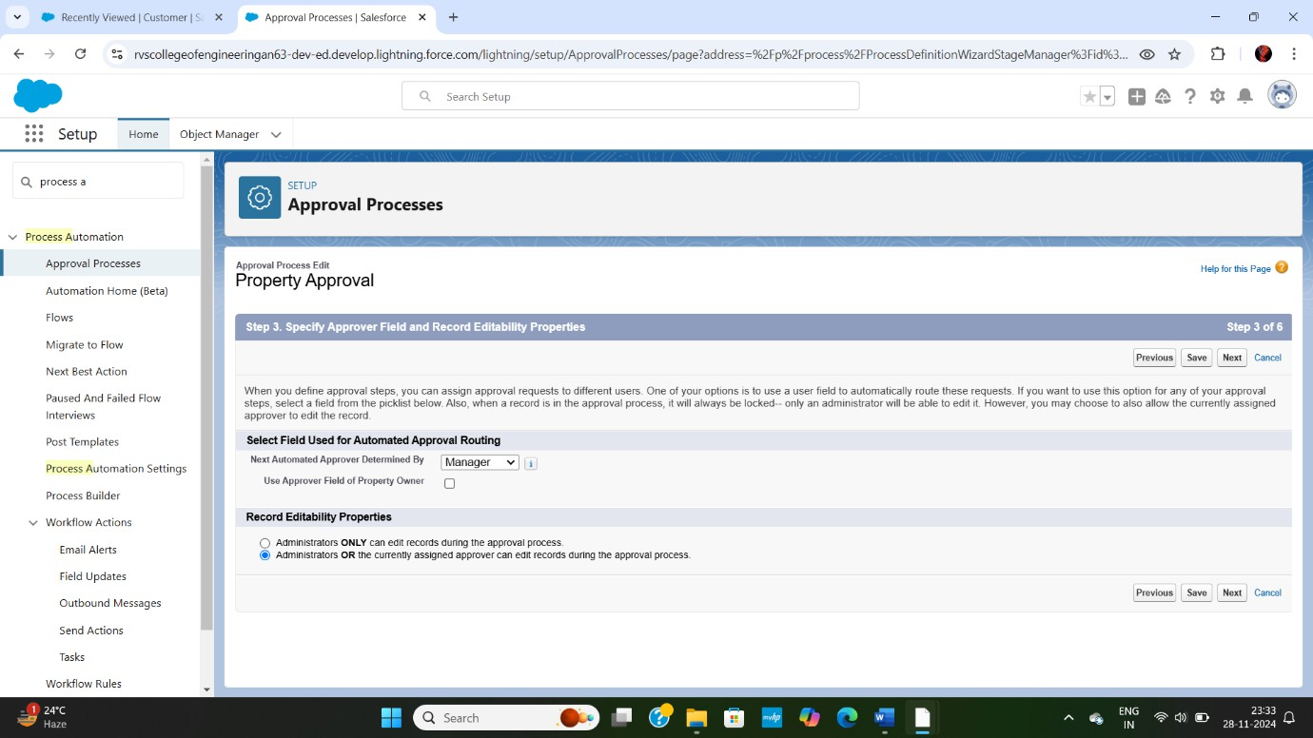

1. From Step Select Fields to Display on Approval Page Layout select Property, Owner, Location, and Type.

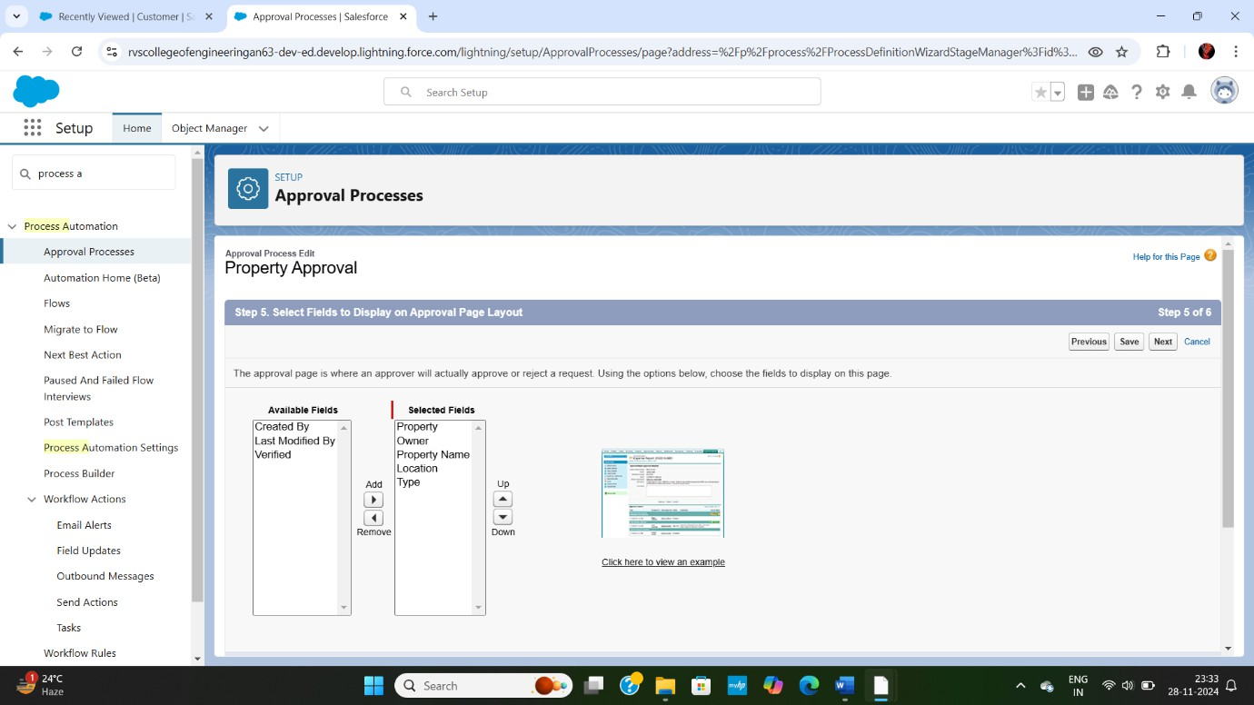

1. Click Next and Select the initial Submitters >>
   1. Owner >> Property Owner
   2. Roles >> Sales Manager

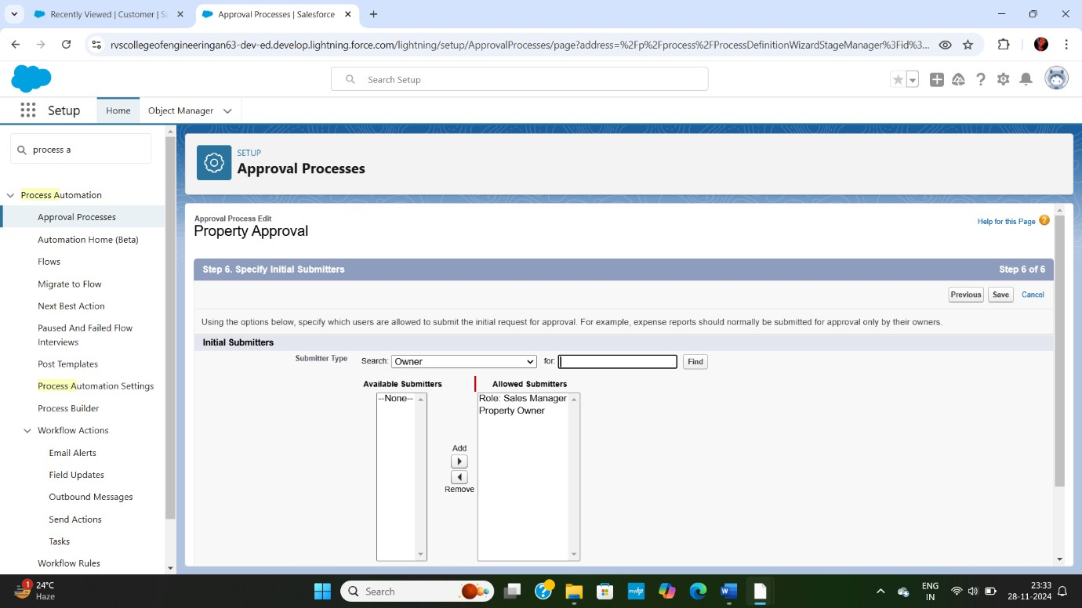

1. Add an approval step name “Executive Approval”; specify the criteria **all record should enter**, click next and select the Approver as “Sales Executive” and “Save”.

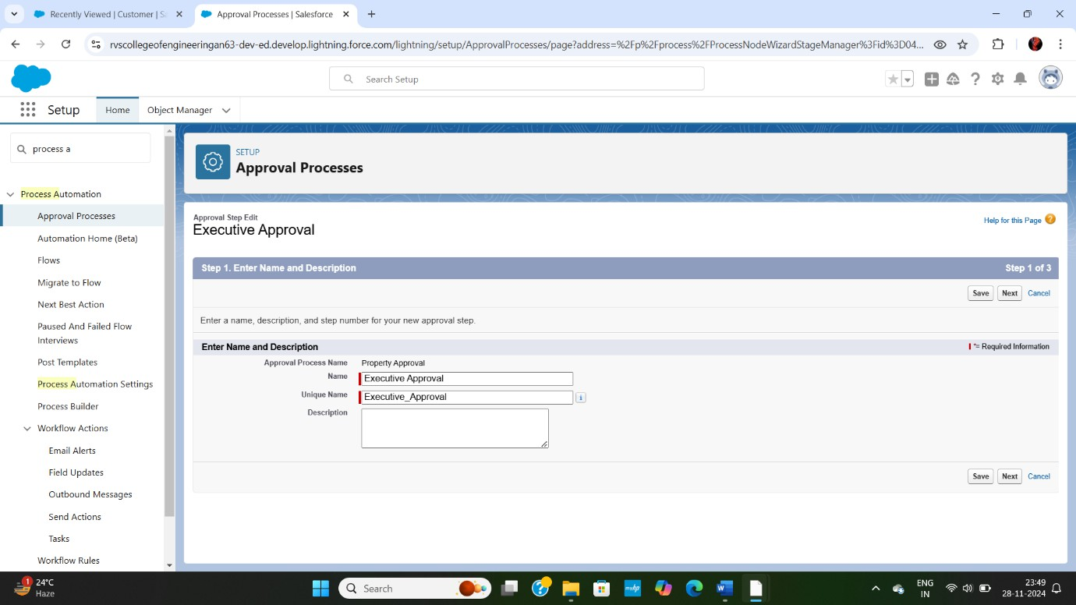

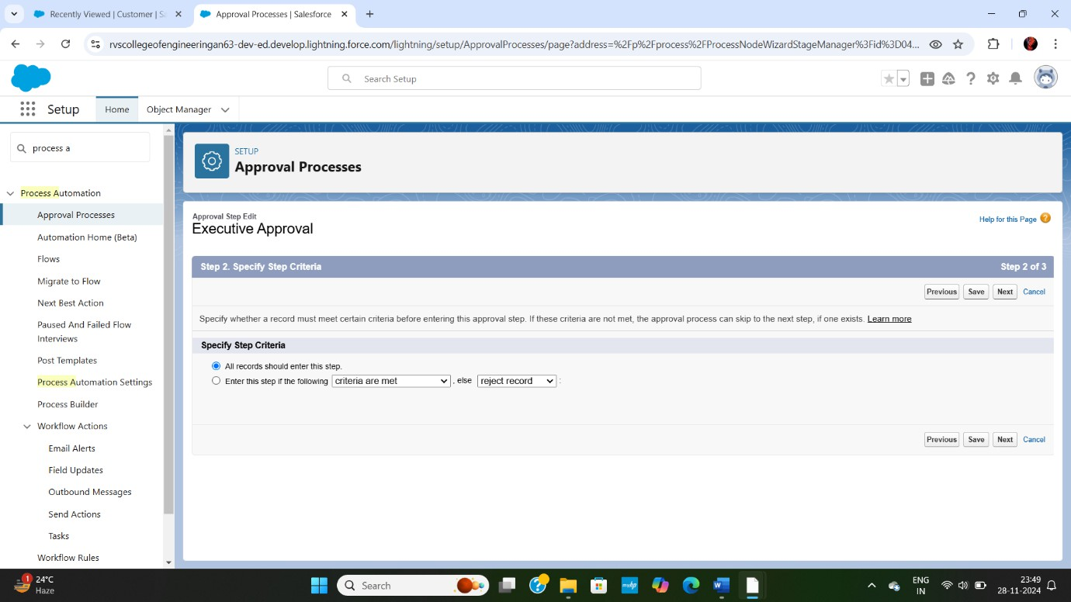

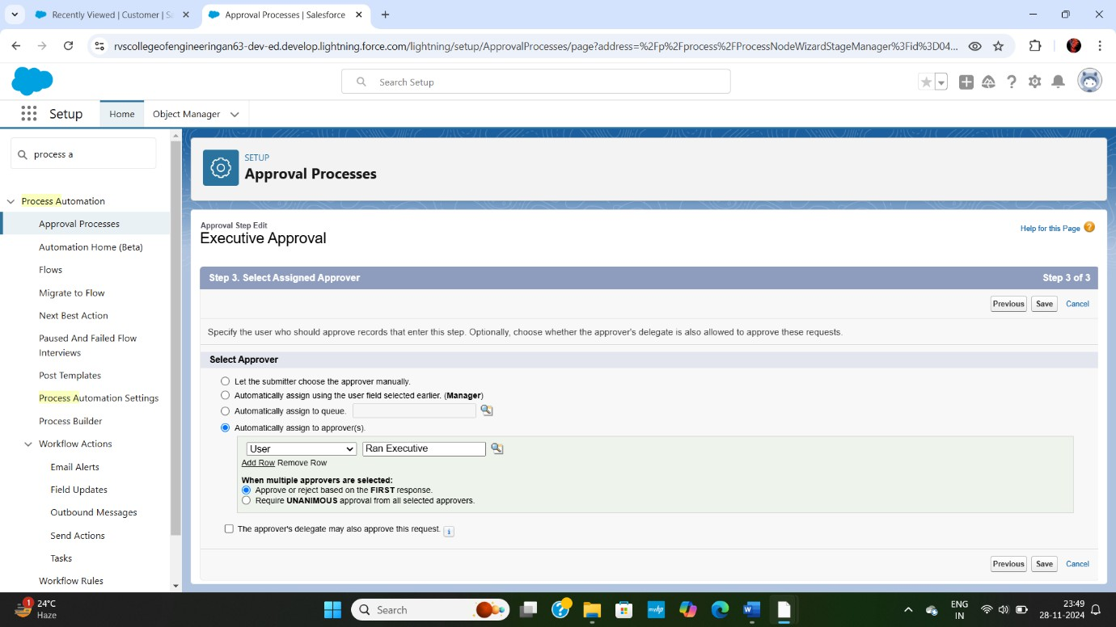

1. Add One field Update as “Verified Property”, Select Object >> Property Field to Update >> Verified Field Data Type >> CheckBox, Select CheckBox Option as “**True**” and save.

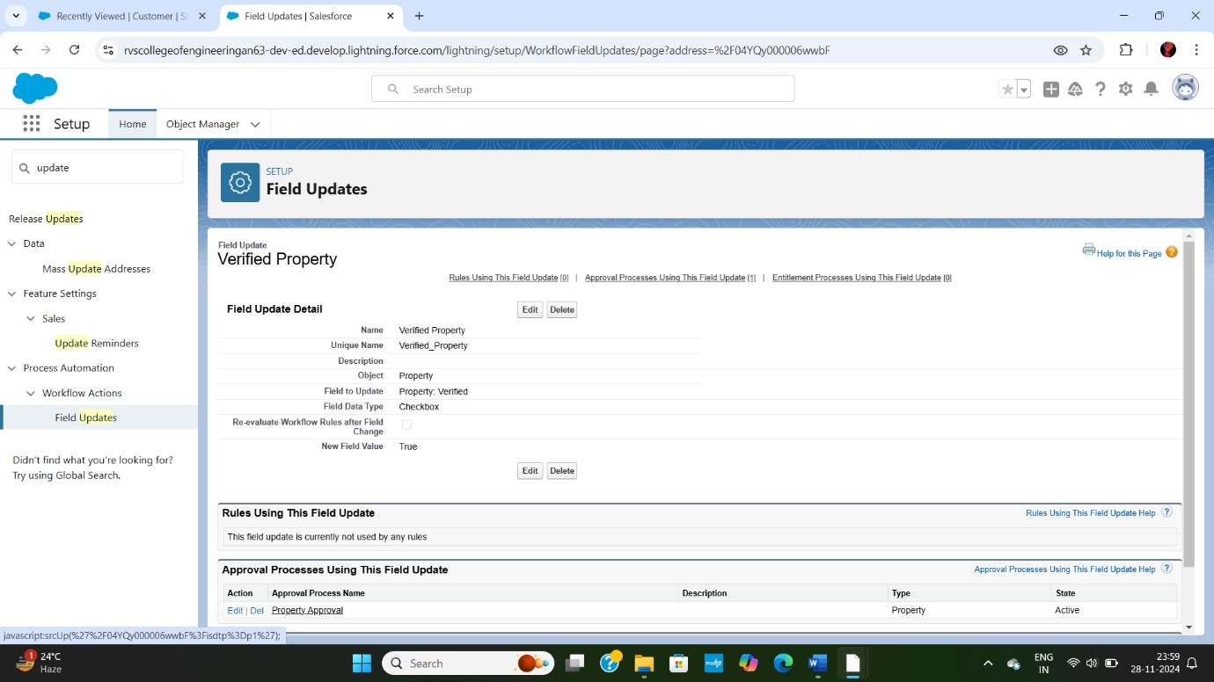

1. Add One field Update as “UnVerified Property”, Select Object >> Property Field to Update >> Verified Field Data Type >> CheckBox, Select CheckBox Option as “**False**” and save.
2. Activate the Approval Process.

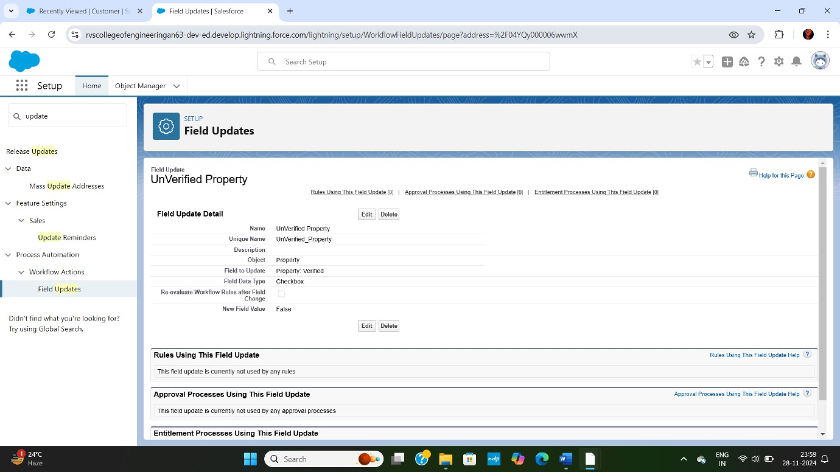

## STEP 10:

Create a Record trigger flow to submit the Approval Process Automatically.

### Activity:

From Setup >> Search for Flows >> Click On New and Select “Record Trigger Flow”; Select Object >> Property; Select “Trigger the flow when” >> “A record is created”; Set Entry Conditions >> “None”; Add a “Action”

>> “Submit for Approval”; Give Label >> Approval for property; Record Id >> {!$Record.Id}; Save the Flow and Give label as “Property Approval” and “Activate”.

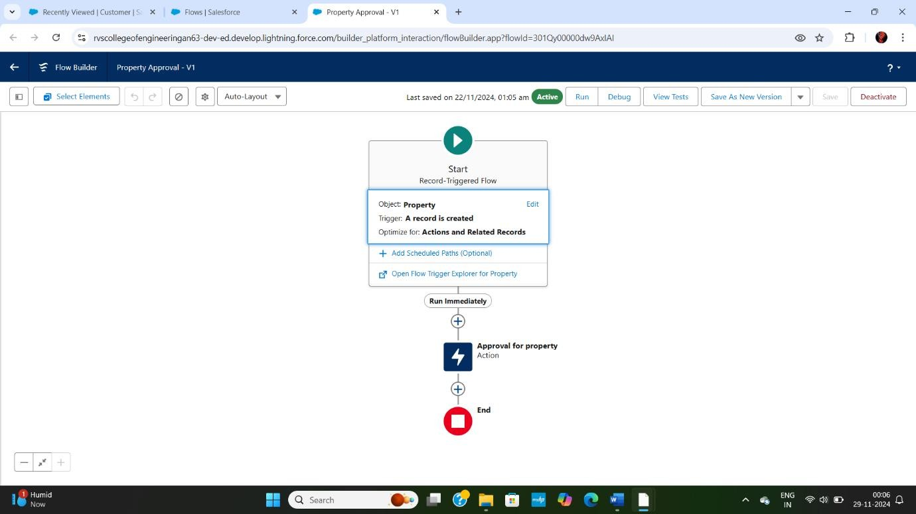

## STEP 11:

Create an App Page.

### Activity:

From Setup >> Go to Lightning App Builder >> Click on New >> Select App Page and Click on Next. Give Label as “Search your Property” click “Next”. Click “Header and Left Sidebar” and click on “Done”. Click on “Save” and then click on “Activate”.

From Page Setting select page activation as Activate for all Users. From Lightning Experience Click on “Property Details” and click on “Add Page” and save.

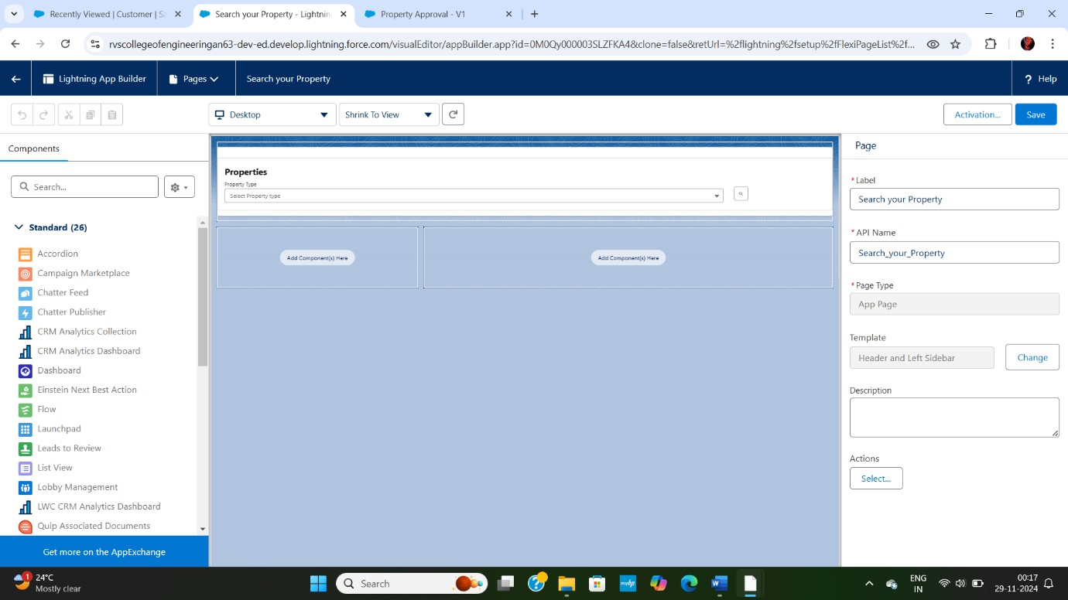

## STEP 12:

Create a LWC Component

### Activity:

Create an Apex Class and make it aura enabled and name it “PropertHandler_LWC”.

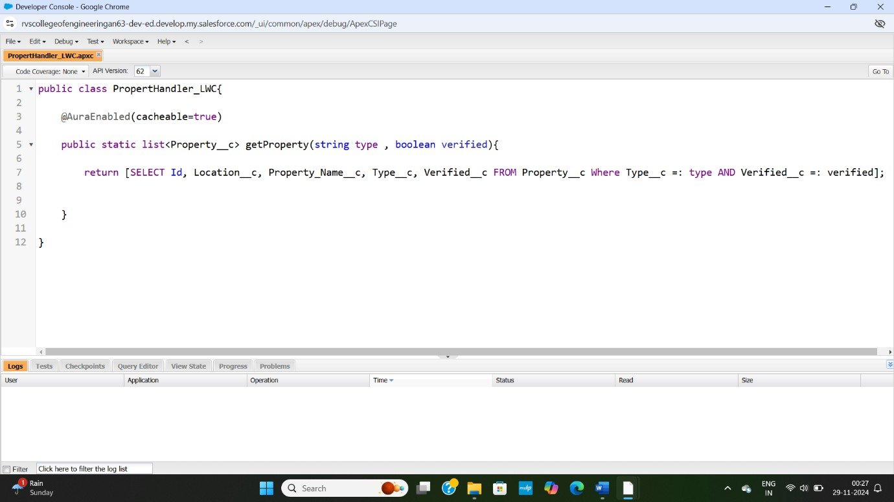

Create a Lightning Web Component in your VsCode, and (ctrl+shift +P) and click on authorize an org. Enter your login id and password to authorize your org. Now (ctrl+shift +P) and Create a lightning Web Component and Name it dream.

1. **HTML file:**

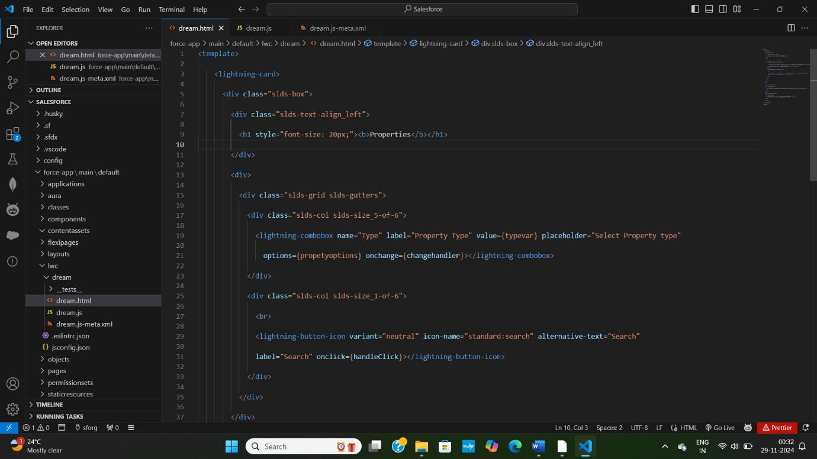

1. **JS file:**

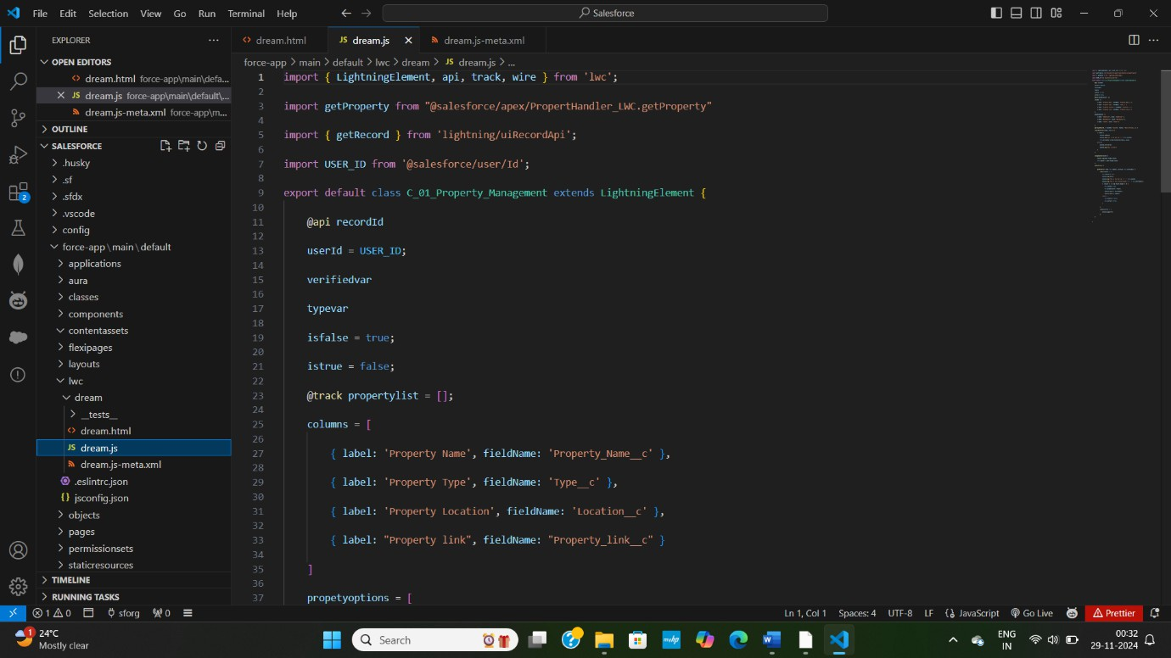

1. **Metafile**

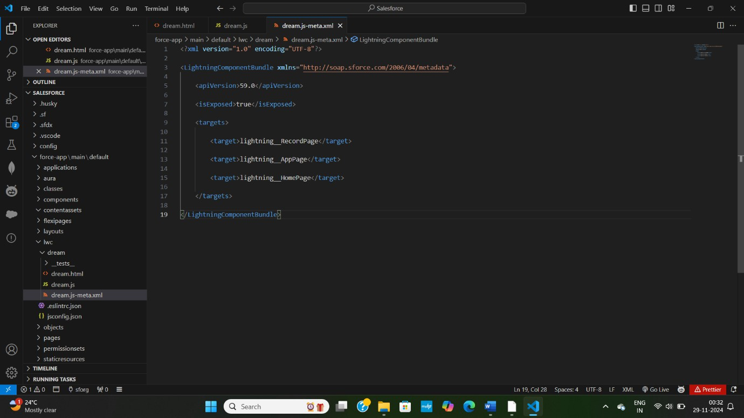

After Saving all the three Codes, Right Click and deploy this component to the org.

## STEP 13:

Drag this Component to your App Page.

### Activity:

From Setup >> Go to App Launcher >> Search for Property Details; On this Page click on gear icon and click on Edit Page. Drag the Component to your App Page and Save the Page.



## STEP 14:

Give Access of Apex Classes to Profiles.

### Activity:

From Setup >> Search for Apex Classes >> Click on “Security” behind “PropertyHandler LWC”. From Profiles Add “Manager” and “Customer” and “Save”.

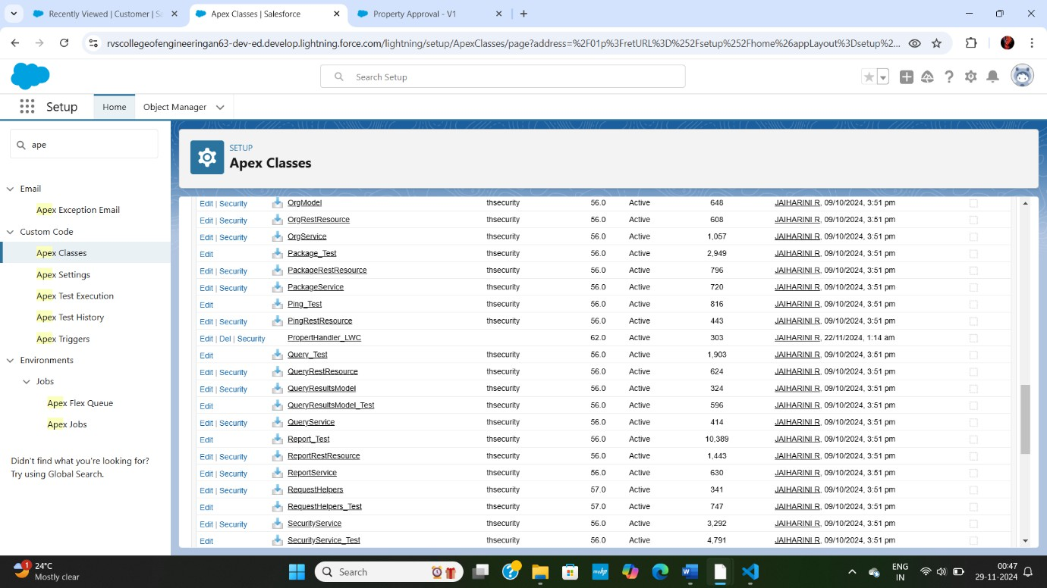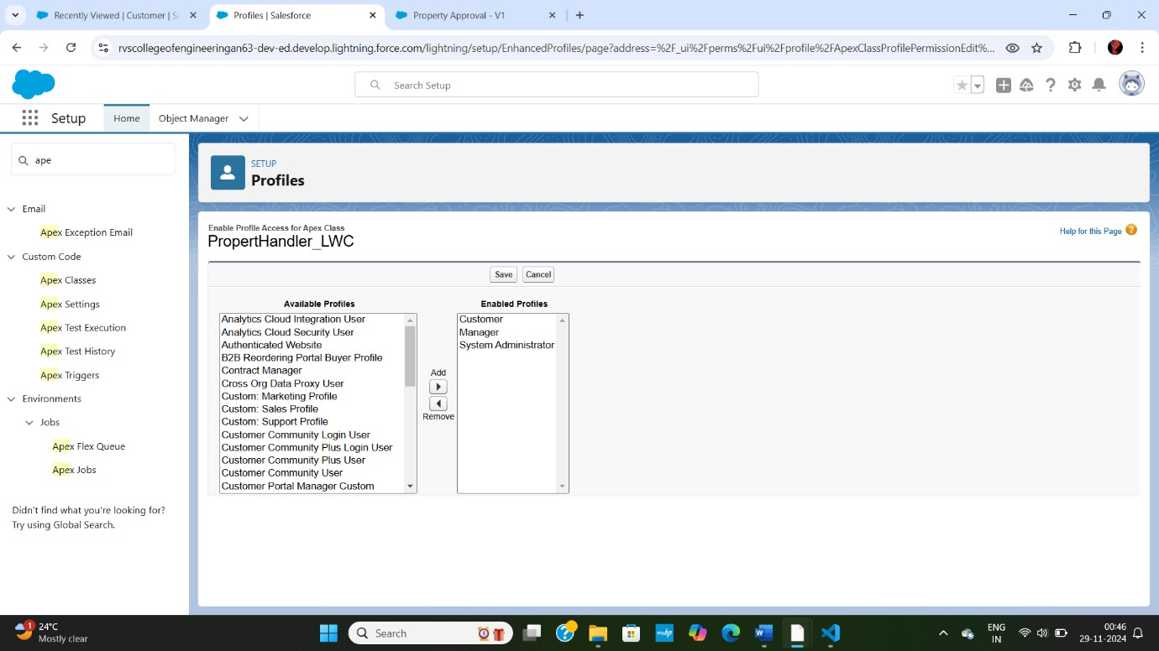

# Testing and Validation

To ensure the Salesforce CRM application meets the required standards, we will employ a comprehensive testing approach, including:

### Unit Testing (Apex Classes, Triggers):

* 1. **Apex Unit Tests:** Write unit tests for Apex classes and triggers to validate their functionality and ensure they meet the required standards.
  2. **Test Classes:** Create test classes to test Apex classes and triggers in isolation.
  3. **Test Methods:** Write test methods to validate specific scenarios and edge cases.
  4. **Code Coverage:** Ensure that the Apex code coverage is at least 75% to guarantee that the code is thoroughly tested.
  5. **Test Data:** Use test data to simulate real-world scenarios and validate the application's behavior.

### User Interface Testing:

1. **User Interface (UI) Testing:** Perform UI testing to validate the application's user interface and ensure it meets the required standards.
2. **User Acceptance Testing (UAT)**: Conduct UAT to validate the application's functionality and ensure it meets the business requirements.
3. **Test Scenarios:** Create test scenarios to validate specific user interactions and workflows.
4. **Test Data:** Use test data to simulate real-world scenarios and validate the application's behavior.
5. **Browser and Device Testing:** Perform testing on different browsers and devices to ensure compatibility.

# Key Scenarios Addressed by Salesforce in the Implementation Project

### Client Onboarding:

* + 1. **Scenario:** Automate client onboarding process to reduce manual effort and improve client experience.
    2. **Salesforce Solution:** Utilize Salesforce's out-of-the-box features, such as Account and Contact creation, to automate client onboarding. Leverage Process Builder and Workflow to assign tasks and send notifications to relevant stakeholders.

### Property Management:

* + 1. **Scenario:** Manage property-related information, including property type, location, and ownership details.
    2. **Salesforce Solution:** Create a custom object, "Property," to store property-related information. Utilize relationships to link properties to clients and accounts.

### Service Management:

* + - 1. **Scenario:** Manage various services offered to clients, including property maintenance, repairs, and renovations.
      2. **Salesforce Solution:** Utilize Salesforce's Service Cloud features, such as Cases and Work Orders, to manage service requests and delivery.

### Reporting and Analytics:

* + - 1. **Scenario:** Provide insights into client interactions, property management, and service delivery.
      2. **Salesforce Solution:** Leverage Salesforce's reporting and analytics features, such as Reports and Dashboards, to provide real-time insights into key business metrics.

### Security and Compliance:

* + - 1. **Scenario:** Ensure the security and integrity of client data and comply with regulatory requirements.
      2. **Salesforce Solution:** Utilize Salesforce's built-in security features, such as encryption and access controls, to protect client data. Leverage Salesforce's compliance features, such as GDPR and HIPAA compliance, to meet regulatory requirements.

# Conclusion:

Dreams World Properties integrates Salesforce to streamline customer interactions. Website engagement triggers automated record creation in Salesforce, capturing customer details and preferences. Salesforce categorizes users as approved or non- approved, offering tailored property selections to approved users. This enhances user experience and efficiency, providing personalized recommendations and broader listings. Seamless integration optimizes operations, improving customer engagement and facilitating growth in the real estate market.

**8.Result:**

Thus the CRM (Customer Relationship Management) application using Salesforce to manage clients and their property-related information is designed and developed. The application will enable the organization to streamline client interactions, property management, and related services.